Qualitative Plan

3 YEAR PLAN FOR INECO S.p.A.
FY13- FY15

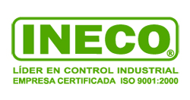

By: Cristian Glenz

June 2012

- Introduction

- Economic and Business outlook

- SWOT analysis and Competitive analysis

- Commercial Plan FY13-15

- Operational Plan FY13-15

- Organization Plan FY13-15

- Financial Plan FY13-15

- Appendix: Historic data and trends

- INTRODUCTION

This document presents a Qualitative Business Plan for INECO for the next 3 years. It starts with an economic and business outlook for Chile, and later presents a Commercial, Operational, Organizational, and Financial Plan for the company for the period FY13 to FY15. This is a first draft that covers mainly the strategic aspects of the Business Plan.

Ineco has completed its third year with Puffer-Sweiven, a larger organization that offers several complementary products and services for the Instrumentation and Controls market. This should help the company grow at a faster pace using Puffer´s support in Capital and positive positioning and relationship with several key Principals.

At the same time, this paper addresses the opportunities in Maxcontrol, particularly with the new CQM representation to address Energy efficiency needs in our market.

- ECONOMIC AND BUSINESS OUTLOOK

Chile has obtained stability and the favorable reputation for doing business with an open economy in a region where several neighbors have been questioned by international parties (IMF, WB,…) for going just the opposite. Chile bases its economy in the export of commodities, with copper counting for nearly 50% of the total. The price of copper has experienced a continuous growth since its lowest price in 2001, where it reached 0,58 US/lb. Currently the price is above 3,40 US$/lb, and it is expected to remain above 3,00 US$/lb in the long-term.

The country counts with a steady democratic system with Municipality elections coming up by the end of 2012, and Presidential elections in Oct 2013 that should maintain the successful economic system, but that also should address more aggressive social demands by the rising middle class, particularly in areas of education as well as environmental matters.

At the same time, there is uncertainty in how the world will grow going forward particularly how the European crisis will affect other more relevant markets for Chile such as the US and China. The BRIC group will also experience a slower growth cycle causing a potential reduced demand for commodities such as copper and other metals.

For 2012 to 2015, the economic indicators project:
 | 2012 | 2013 | 2014
GDP | 4,5% | 4,8% | 5,0%
Spending | 9,0% | 7,5% | 7,0%
GFI | 9,4% | 5,2% | 5,6%
Inflation | 2,5% | 2,8% | 3,2%
Interest rate | 5,0% | 5,5% | 6,0%
Dollar | 500 | 525 | 530
Exports $b | 87 | 92 | 98
Imports $b | 73 | 81 | 89
Int´l reserves $b | 40 | 42 | 44
Unemployment | 6,9% | 7,2% | 7,5%
Fiscal surplus | 1,3% | 0,5% | 0,5%
Copper price | 3.40 | 3,20 | 3,30
Oil price WTI | 80 | 85 | 90

(*) Source: Diario Financiero April-July 2012 publications

The investment expected for the next 8 years (2012-2020) is significant and exceeds $150 billion across all industries. Most of this opportunity is in the M&M and Power industries, but there is uncertainty that several of these projects will be executed in a timely matter due to the following factors:

- Difficulty in the financing of large capital projects in the world
- Lack of specialized engineers and technicians
- Environmental and Social pressure in the Local communities
- Power availability for these large new plants

Only in Power projects, there is 38% of the 32900 MW of available projects in risk of not being executed due to one of the previous reasons.

The top 24 Mining projects in Chile account for more than $100 billion of investment for the next 8 years.
US$ million
Codelco Andina | 6.270
Codelco Radomiro Tomic | 4.500
Codelco Chuquicamata | 3.828
Codelco Teniente | 3.039 | 21.866 (Gov´t owned copper producer)
Codelco Ministro Hales | 2.300
Codelco Gaby | 967
Codelco Salvador | 962
AMSA Ampliacion Pelambres | 10.000
AMSA Antucoya | 3.000
AMSA Telegrafo | 3.000 | 19.000 (Largest Chilean Private Copper producer)
AMSA Caracoles | 3.000
BHP Ampliacion Escondida | 5.500
Anglo-Xstrata:Ampliacion Collahuasi | 6.500
Barrick- Cerro Casale | 6.000
Barrick- Pascua Lama | 3.000
Teck-Quebrada Blanca | 4.200
Teck-Relincho | 3.900
Quadra- Sierra Gorda | 3.100
Goldcorp-El Morro | 3.900
CAP- CMP | 3.000
Exeter-Caspiche | 4.800
Nippon-Mitsui: Caserones | 3.000
SQM | 3.000
Los Andes-Vizcachitas | 2.500
Lomas Bayas | 1.900
Other | 8.100
 | 103.266

- SWOT ANALYSIS AND COMPETITION

Given the country´s economical and social stability, as well as the important amount of investment activity, several competitors are increasing their presence in Chile.

Samson and E+H have increased their sales force and have become very aggressive in project pursuit.

Neles enjoys a strong presence in Chile given that they belong to Metso, one of the largest OEMs in the most important industries in Chile, M&M and P&P.

Dezurik has a presence in the northern (M&M) sector, with little presence in the rest of the country. Their strategy is always price and it is represented by Zurich Chile.

Masoneilan has a weak presence in Chile. They compete with us only in the Refineries, particularly in the EBB where they have the largest installed base. Their sales and presence have decreased given the slow level of investment in the Bio-Bio Refinery.

ABB is the largest SYS provider in Chile with near 50% of the market share, and uses Chile as their main hub for Mining projects worldwide.

Invensys has a strong presence in Chile. They closed an agreement with Xstrata for the next 4 projects in the region, and normally they use very aggressive pricing in projects.

Honeywell has a strong presence to support their installed base, which are the Refineries and some Codelco sites. They currently have a joint venture named Kyros with Codelco to migrate all their Concentrator plants, but this agreement is on jeopardy and Codelco is opening the opportunity to other vendors.

Yokogawa opened an office in Santiago 3 years ago, but have very limited installed base (only the LNG Regas facility in Quinteros and currently they just won a large M&M project with Caserones that had Japanese investors). They are also experiencing a change in management given their poor sales performance, and have just hired a new General Manager (he used to be Ineco´s Rosemount Sales Manager). They have lost their key Systems Sales Manager (that was hired by Ineco) and is about to fire the existing Instruments Sales Manager.

Emerson is planning to open a M&M center of Excellence in Chile, which could jeopardize our existing business and positioning with our customers.

The local companies Soltex, IMA, and Ineco experienced double digit growths in CY11. IMA has taken advantage of their new offices in Argentina, Peru, and Colombia to offer their services. Additionally they participate in the larger electrical market and have taken advantage of these opportunities. Soltex experienced a significant growth both in Sales and Operational Profit. Bermat has been decreasing their presence, size, and sales in the market, particularly after losing the Emerson lines in FY10. There are several smaller companies that are growing in their particular niches: Maxcontrol, Pessa (that was going to be purchased by Puffer in the Ineco package), Scancontrols (competes with Ineco in services in the north), and Zurich (represent Dezurik). Tecma that works almost exclusively with Masoneilan has been losing presence in Chile as they overly depend on the Bio Bio Refinery that has been investing very little.

The following tables reflect the results of several of these competitors in CY11:
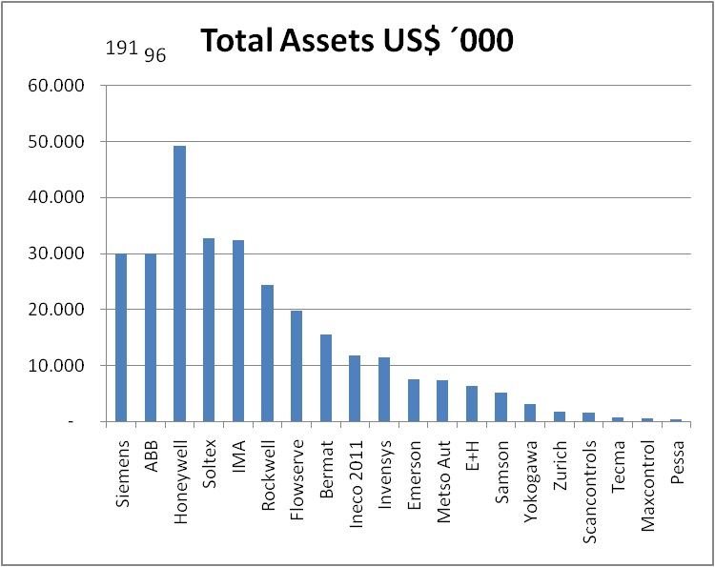

Siemens and ABB have a significant larger Balance Sheet than the rest of the players, followed by Honeywell due to the joint venture with Codelco. Next, there is a group of 7 companies including Ineco in the middle tier that have Total Assets between US$10 and 30 million. At the end of the scale there are the smaller local companies that are increasing in size.
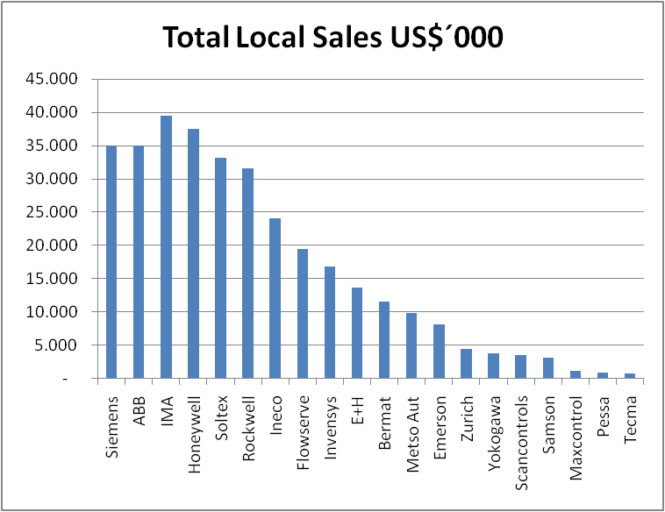 | 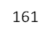  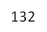
Again Siemens and ABB are much larger than the rest of the companies in Chile with Sales above US$130 Million. This is mainly due to their presence and offering in the larger Electrical market. Then, there is a group of 5 companies including Ineco that have sales above US$20 Million. Yoko is the company that grew the most doubling their Sales, mainly due to the large Caserones project they won in 2011. Then Maxcontrol and Scancontrols grew at more than 70%

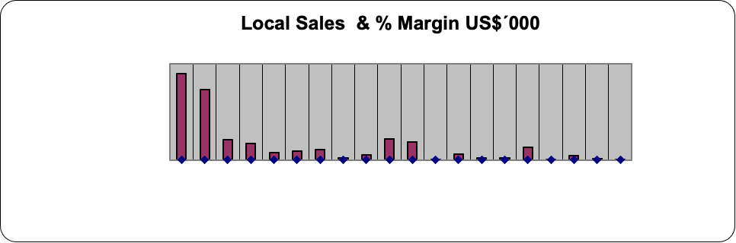

Except for Pessa that sells mostly services and engineering, and Maxcontrol that receives commissions from Ineco at 100% GM, most of the players range between 33% and 38%. Several direct manufacturers have numbers between 40% and 51%, but it is unknown if this includes subsidizing their business in Chile.
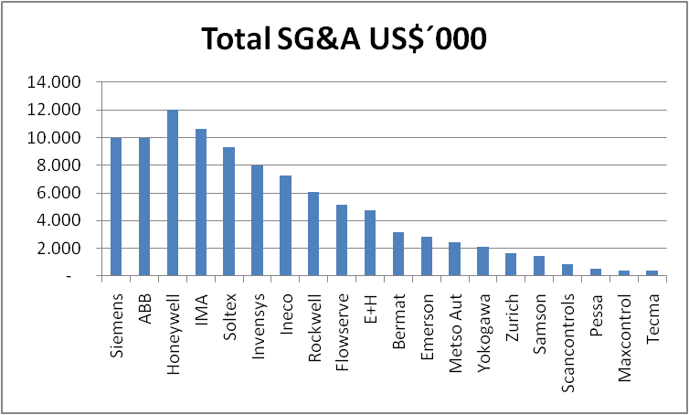
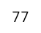
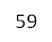

Siemens and ABB have much larger organization compared to the rest of the companies with. This is reflected in the SG&A figures of $59 and $77 million per year respectively. Then there is a group of 8 companies, including Ineco that have figures between US$4.5 and $12 million.

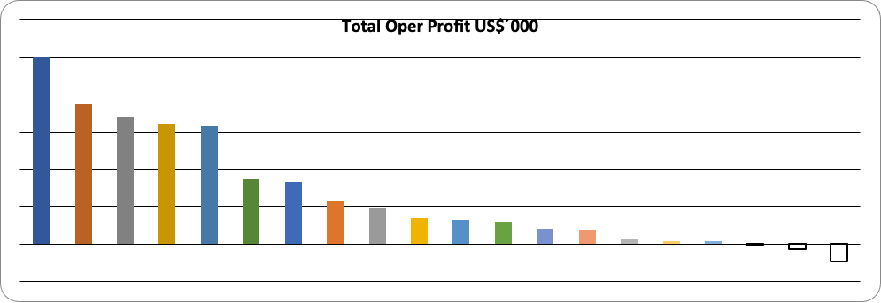

There are 5 companies that exceeded US$3 million in Operational Profit, and there is a second tier that reached between US$1 and 2 million (this group includes Ineco without considering the Inventory and other adjustment done in 2011). Yokogawa, Samson, and Tecma (Masoneilan rep) have negative results.

- COMMERCIAL PLAN FY13-14

Currently, the I+C Market in Chile has the following composition:

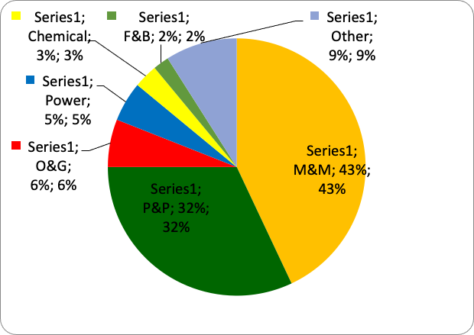

M&M and P&P account for near 75% of the market. It is important to mention that none of these two industries are key for most of our principals (except for Mogas), as they tend to specialize in the O&G and Chemical sector. This has consequences in the level of support they provide us and sometimes in weaknesses in their product offering portfolio.

Based on the list of projects presented earlier, there are several opportunities in M&M that we are currently pursuing. Besides the Power industry, where we have little influence on the project decisions as most of the projects arrive as packages integrated abroad, there are few investments in the other Process industries: The National O&G company ENAP continues to struggle financially and will not be having significant investment in the next few years, in P&P Arauco will have an addition of a new third Fiber Line in the Arauco Plant but will be the only significant investment in that industry, Methanex continues to experience problems with the supply of Natural Gas for their 4 Plants in Punta Arenas, and the rest of the Process industries will have marginal investment. In fact, Methanex will be moving one of their Trains to Louisiana-US in 2013, which will mean losing Installed Base in Chile. Therefore, our focus will be placed on M&M, both in covering the existing plants with our branch offices in Iquique, Calama, Antofagasta, and Copiapo - as well as the new projects being engineered in Santiago.

A potential loss of the SYS business would definitely affect our abilities to engage early in the projects. We are in the process of evaluating maintaining a group of Systems engineers to continue addressing APC opportunities in Chile, as well as to service Puffer Houston with remote configuration. This would imply not having the synergies of offering all Systems business in Chile, and therefore Ineco would need to depend on Puffer Houston to train those engineers/technicians. Additionally, Emerson continues trying to persuade us to assist them in project pursuit for Systems, but the commission available is too low to compensate for this effort. Additionally Ineco needs to decide what to do with Rotork and the VAD Division.

Without the loss of the SYS and ARO business, we project the following numbers for EMERSON in FY13-15:

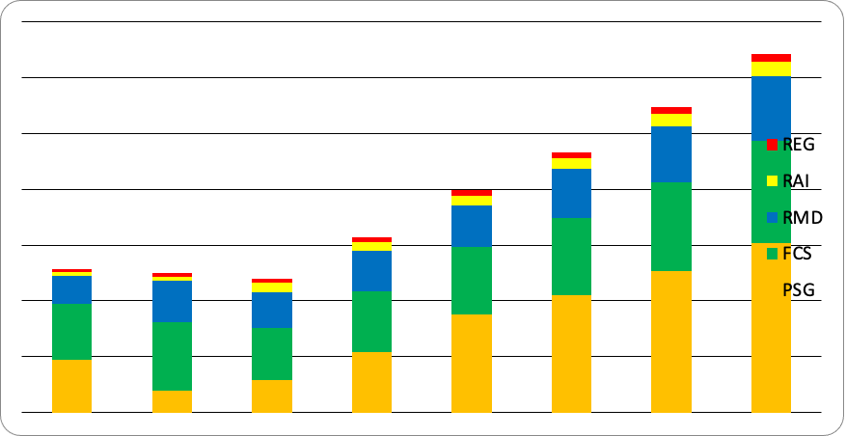
(*) this are Emerson numbers (not total Ineco).

At the same time Maxcontrol is having tremendous success with its new representation around Power Efficiency. This is taking advantage of the needs that the country has in the next few years in terms of possible power shortage and the enforcement of the ISO50.000 standard in Chile. Maxcontrol started covering all existing and new Malls, and has already successfully finished a field trial with this solution with the largest Mall developer in Chile and is waiting for several other Purchase Orders in the next couple of months. Maxcontrol is also pursuing other opportunities in Commercial customers, such as Datacenters and Mining Camps that use an important amount of Chillers. In Process customers there are chances in Mining, mainly in the Cooling Towers, and in Power plants.

Ineco is also studying and evaluating adding the FI and PP divisions to the current product portfolio, which should allow an increase in Revenues.

We are estimating that the FI business is around $25 million, where we are planning to capture a 16% of market share within 3 years. We have 11 companies committed to work with Ineco in this business, and 4 of them account for nearly 70% of the opportunities. Besides the lines that Puffer works in Houston, Ineco is approaching Vendors and solutions that address the Mining industry. This Division should reach around $1 million in Net Revenue in 3 years.

The PP business will be left for a second stage, after FI has been implemented.

Wireless offers Ineco with additional business opportunities with new applications, particularly in Mining.

Another good opportunity for the next 3 years is the new obligation that the Power Plants will have regarding emissions to the environment. This gives our CEMS total solution several chances in more than 26 sites, worth a total business of around $5 million only in FY13. We are aiming to achieve 50% of this market. Additionally, there are service agreements that come with these offering that could assure future MRO.

Lastly, Ineco is experiencing several requests from customers to increase the scope of our services given that they want to focus on their production expertise only. This provides the opportunity to offer additional preventive and predictive (proactive) maintenance services.

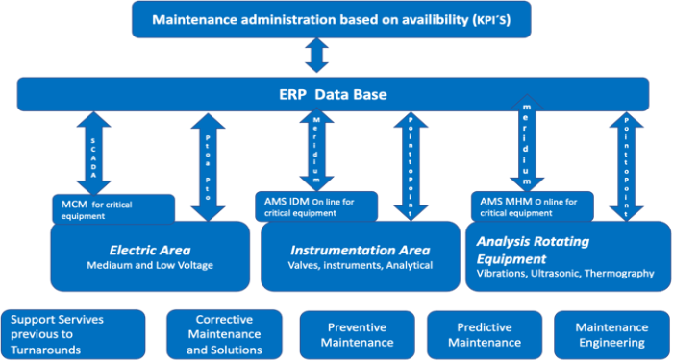

During FY13, Ineco should be working towards getting the FASP certification that should allow us to increase the sales of both services and Fisher spare parts.

So far we have been using the same sales force that sells our field devices to promote our services, but we should evaluate if this is the way we should address this business in the future.

Mogas has added a person in Chile to support our business, and we convinced them to hire an Ineco employee (this helps us avoid working with somebody that does not know us). Eventually this event would not allow us to keep high NR, as this person could have access to our pricing from feedback from customers. We are working with Mogas to limit the scope of work of this person only to technical support in our territory, and not to any commercial discussions with customers.

Key activities with VIP customers:

Ineco is working to have a long-term contract with AMSA, the largest Private Copper producer in Chile, as we have 3 of their 4 existing sites, and the largest brown field investment in Chile will be at the Pelambres site. AMSA, besides Pelambres, has several green field projects going forward. So far, we have a Systems contract with Pelambres, and now we are working on adding the rest of our products and services.

Ineco is working towards getting an entrance at Codelco that has been dominated by a joint-venture that they have with Honeywell, but that has been questioned by the new management in the last year.

In P&P, Ineco has more than 50% of the Installed base, particularly with Arauco where that figure exceeds 65%. Ineco is working to have a long-term service agreement with Arauco that includes both PO placed to Emerson (Guardian) and to Ineco (not only Systems support, but also field devices and services). Arauco will have a $1.5B investment in its Horcones Plant that will have the RFQs around Dec 2012.

- OPERATIONAL PLAN FY13-15

Ineco will be relocating to a new office in Santiago in Jan 2013 that should allow to integrate the Sales, Operational, and Wareshop activities in one single location. Ineco will also be working in FY13 to obtain the ISO 14,000 and ISO 18,000 certifications that will be important to participate in any sales and service activity in the future, particularly in Mining. Ineco will also be pursuing in FY13 the FASP certification.

During FY13, Ineco will continue to improve our service capabilities, particularly in our Antofagasta office and the FASP certification should help in this direction.

Maxcontrol is working with a third party Lherma, that assists on the installation of the CQM solution. This will allow to not increase the headcount of the company in Service.

- ORGANIZATIONAL PLAN FY13-15

During FY13, Ineco should be replacing the current Sales Manager that should be returning to Houston. Ineco is in the process of finding his replacement in order to have him start working in the company before Oct 2012 to allow a smooth transition.

Ineco is also working with a new Service organization, where Rodrigo Matus has taken a lead role in Mechanical service in all branches. This should help facilitate the FASP certification with Fisher as well as help us validate another external Wareshop for Mogas and retrofit services in Santiago and allow us not to depend only on Backup Wareshop.

Ineco will continue to consolidate the sales organization based on account management in all branches. No important headcount increases are expected until the Systems and ARO situation is resolved. Eventually, Ineco will have to reduce SG&A to compensate for the loss of those businesses.

Ineco is also evaluating adding additional divisions (FI this year), therefore an increase in headcount is expected for this reason. Overall, Ineco should be increasing the headcount in around 6% in FY13 compared to FY12.

The Chilean labor market continues to be tight. The current unemployment rate is at its lowest, making it very difficult and expensive to find engineers and technicians. The EPCs and Mining companies are recruiting many of our people with wages that are 2 or 3 times what they earn with Ineco.

Given the existing labor market pressure, we will need to continue monitoring the compensation packages to retain key employees. Ineco should project a minimum increase in salaries equivalent to the inflation rate, plus an effort to retain key employees. Our HHRR group will continue to play a key role promoting non-compensation motivation activities and items within the organization. Communicating our vision, Performance Evaluation, Health life promotion (sports and healthy food), internal Stress handling activities, Leadership development, etc. Ineco is developing an intranet that should also assist and support these activities.

Maxcontrol has been increasing the number of headcount to address the CQM business, and has added in FY12 a Sales Manager, one outside sales to cover the commercial segment, and other 2 outside sales that are shared with the I+C segment to cover the industrial customers. Additionally there is one inside sales fully dedicated to the EE business and one inside sales that is shared with the I+C to cover the project and solution opportunities. This organization is enough to address the business in FY13, but should be increased in FY14 and FY15 depending on the response and attractiveness of this new market.

Ineco and Maxcontrol will continue to look for opportunities to become more efficient having always the goal of making SG&A increase at a lower rate than NR. Sharing productivity information with other Puffer entities should help Ineco and Maxcontrol improve this indicator.

Retention plan, what are we doing,…non-compensation plan, what do I expect the payroll to increase (inflation,….).

How to get Efficiencies, projection of headcount next 3 years,

- FINANCIAL PLAN FY13-15

Ineco will be moving to a new office in Santiago in Jan 2013, to a property that should allow more interaction between areas and the possibility of having the integration of offices and warehouse/wareshop in one single location. This should imply an increase in SG&A (facilities) of around $150K per year.

Ineco is also working towards getting our Northern shop certified by Fisher as FASP. This should allow us, not only to win additional spares and service business, but also to not continue market share in the largest M&M territory. This implies an investment of around $330K with a projected return of investment of 1 to 1.5 years.

Below is the initial general forecast for the next 3 years for both cases, with and without PSG. This assumes the loss of the PSG and ARO businesses, except for the APC and Remote Systems configuration services for Puffer Houston.

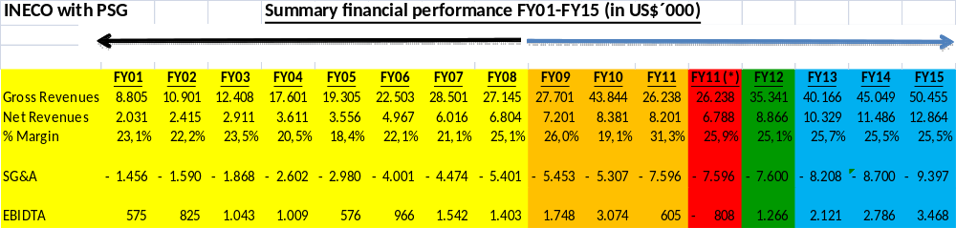
(*) FY11: An adjustment of $1,413K of old Inventory was applied

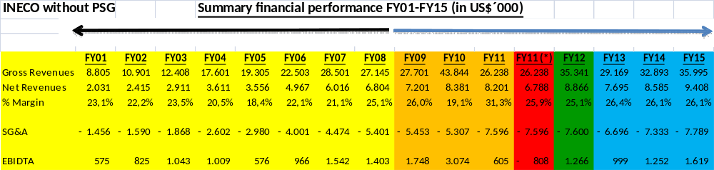
(*) FY11: An adjustment of $1,413K of old Inventory was applied

assumes 4 SYS people in FY13, 5 in FY14, and 6 in FY15

CAPEX, Inventory Mgmt Plan, Training, vehicles, IT

Ineco is also addressing the current Inventory liquidating older product with incentive programs and at the same time managing any future Stock additions.

On the other hand, Maxcontrol should experience a tremendous growth with the CQM opportunity and should be able to double the size of that company within the next 3 years. Maxcontrol provides Ineco with the possibility to diversify from its I+C business, extending the reach to the Power Efficiency segment.

An initial projection for Maxcontrol for FY13-15 is:

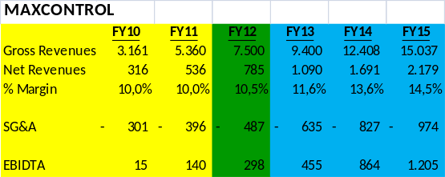

- APPENDIX: HISTORIC DATA AND TRENDS

Ineco has experienced continuous growth in the last decade, based on the opportunities generated by the Automation market in Chile that has grown in a steady and healthy manner.

Ineco has achieved this growth due to 4 main strategic DRIVERS:

- Representing the world leaders in the automation market and being able to integrate their technology in our solutions (Focus on Principals)
- Developing our people to have the best sales and service specialists (Focus on our People)
- Staying close to our customers extending our regional coverage with sales and services offices close to our end users (focus on our Customers)
- By including Quality processes in everything we do (focus on Quality)

Between 1985 and 2009, Ineco was a family owned business that grew constantly and was able to reach a recognized status in the Chilean Market, mostly as one of the preferred companies to do business with in Automation market in Chile.

In the initial stages, Ineco focused on obtaining strong relationship with leading Principals in our field and focused on being successful in Sales in order to obtain a reasonable Installed base that would allow the MRO business to finance our base operations.

In 1996, Emerson launched Plantweb and Delta V, and despite that Ineco was already involved in Services for field devices, the company started expanding its capabilities to System´s design, configuration, staging, and engineering. During the first 3 years of selling Delta V, Ineco was able to achieve the recognition of the market as a “high quality” and “great service” provider in the DCS segment and was able to sell several small to medium projects. In 2000, Ineco was selected for the largest digital M&M project in the world at that time that opened the door for a future relationship with the AMSA group (largest private Mining company in Chile). In this phase, Ineco had around 35 employees and 3 sales offices.

In year 2002, Ineco won and executed the largest digital project in P&P in the world up to that date with the Arauco group (largest P&P producer in the southern hemisphere), that before this project used exclusively ABB in their systems. This opened the opportunity to position the company as a leading DCS provider and to grow the number of employees to around 70, and 10 years later dominate the P&P with more than 50% of the entire automation installed base, and in the case of Arauco around 65% of all their automation needs.

In 2006, the shareholders of Ineco started the company Maxcontrol as a way to diversify from the current business. This also offered the opportunity to better serve the V Region as Maxcontrol would be located in Viña del Mar. Maxcontrol suffered the consequences of the financial crisis within ENAP, the customer that accounted for 65% of their sales, and has not delivered the expected results until FY12. In the meantime, Maxcontrol has attempted to diversify their business extending the number of customers and searching for other principals in other markets (electrical). In FY10, Maxcontrol had accomplished an interesting and expecting position in Chile with Ventyx and their “Smart Electrical Grid” solution, but this company was purchased by ABB. In 2011, Maxcontrol identified another opportunity with CQM and FY13 and beyond look very promising with this solution that help industrial and commercial customers reduce their energy consumption.

In the middle of FY09, when Ineco and Maxcontrol had around 165 employees, 5 offices and Sales above $27 million, it was sold to the larger and reputable Puffer-Sweiven company, which had a long and successful history with most of the same Principals. This gave access to stronger ties with the existing main Principals, access to more Capital in order to speed the investment and growth of the company, as well as possibilities for additional products and services, and other synergies such as the sharing of some services and back office support.

During the first period of FY09 and FY10, Ineco achieved good financial results but in FY11, the company experienced a significant reduction in accounting profits due to Inventory adjustment given the new owner´s internal Inventory policy. At the same time, Ineco experienced a loss of the financial team that resulted in a lack of financial control. Fortunately before the yearend FY11, Ineco was able to hire a stronger and solid financial team to help us manage our future growth.

In FY12, Ineco has achieved the alignment with Puffer-Sweiven, but is experiencing a tremendous set-back by our main Principal who pretends to take one of our largest and most strategic businesses away from us in order to help them finance their M&M Excellence Center that they plan to open and be based in Santiago. Despite, there are several opportunities going forward with our business, both in terms of market expansion and new products and services, it is not totally clear how the loss of the Systems and AO business would affect us. It also unknown at this point if the loss of AO would also mean losing the AMS IDM business, which we are projecting with interesting growth.

Therefore, this FY13-15 plan will assume the loss of the total SYS and AO business, except for the service portion that Ineco provides remotely to Puffer Houston with 6-7 engineers, and also keeping the APC business. On the positive side Maxcontrol has had very positive results with its new business based on Power Efficiencies that project a successful business into the future. At the same time, Ineco will add additional divisions first with the inclusion of the FI Division, and later the PP Division that also has a good portion of service business.

